

| Mineral oil hydrocarbons in food  and food packaging |
| --- |
| "" |

August 2018

Table of Contents

Summary

Acknowledgements 3

Objective 3

1 INTRODUCTION 4

1.1 What are mineral oil hydrocarbons (MOHs) 4

1.2 The use of mineral oils by the food industry 5

1.3 Factors which can influence MOH transfer from packaging to food 5

1.4 Regulatory provisions for the use of mineral oils in food and packaging 6

2 Methodology 7

2.1 Sampling 7

2.2 Sample preparation 8

3 RESULTS 9

3.1 Phase 1: Quantification of MOH in paperboard packaging only 9

3.2 Phase 2: The analysis of MOH in food packaging and products contained within 9

3.3 Additional analysis of MOSH and MOAH in chocolate cake 10

3.4 Relevance of results to health risk assessment 10

3.5 Discussion 10

## SUMMARY

Mineral oil hydrocarbons (MOHs) occur in printing inks and adhesives used on food packaging, which can potentially migrate into food contained within. Food packaging derived from recycled material, while environmentally friendly, may retain high levels of MOH, from original use.

MOHs are categorised into two main groups referred to as either saturated or aromatic hydrocarbons, herein referred to as MOSH (Mineral Oil Saturated Hydrocarbons) and MOAH (Mineral Oil Aromatic Hydrocarbons), respectively.

In 2014, FSANZ commissioned a two phase analytical program to investigate the migration of MOH from paperboard packaging into foods. This work was conducted as part of the FSANZ proposal, P1034- Chemical Migration from Packaging into Food[1].

Phase 1

The first phase of the analytical survey established a method for the detection and quantification of mineral oils in paperboard packaging. A total of 61 paperboard packaging samples were analysed. MOAH and MOSH were detected in all food packaging samples, with MOSH levels generally higher than MOAH in actual food packaging tested. A strong correlation was found between the level of MOH detected and the proportion of recycled material used in the packaging.

Phase 2

The method established in phase 1 was then utilised in phase two, with a small scale analytical survey, detecting MOH levels in the packaging and corresponding food samples. MOSH and/or MOAH were only detected in two food types (couscous and chocolate cake) tested indicating the levels of these compounds in Australian foods as a result of migration from food packaging are very low.

On the basis of the low incidence of detections in sampled foods a quantitative risk assessment was not justified. It is concluded that the levels of MOSH and MOAH in the Australian food supply due to migration from food packaging are unlikely to be of public health concern. While the results indicate that the dietary exposure to MOSH and MOAH is likely to be low, MOAH contamination of food should be kept as low as reasonably achievable.

## Acknowledgements

FSANZ would like to thank National Measurement Institute for the laboratory analysis on the packaging and food samples, in addition to assisting with some sample collection.

## Objective

The objectives of this survey were to:

* establish an appropriate analytical method for quantifying MOH in food and product packaging
* determine the concentration of mineral oil hydrocarbons in food and associated packaging
* determine the types of foods containing MOH
* to assess whether there are any potential health and safety risks for consumers associated with the consumption of food containing mineral oil hydrocarbons.

# Introduction

## What are mineral oil hydrocarbons (MOHs)

Mineral oil hydrocarbons (MOH) are a large group of organic chemicals found ubiquitously in the environment.

They are predominantly produced from crude mineral oils, but can also be generated from coal, natural gas or biomass. MOH can be transferred to food from the air, ocean environments as well as machinery used in food production.

MOH is an approved food processing aid in the Australia New Zealand Food Standards Code (The Code), and often used in food product packaging, providing further potential exposure of the food to MOH (Figure 1) (EFSA 2012).

### Figure 1: Stages in the food manufacturing process where mineral oils may be used≠

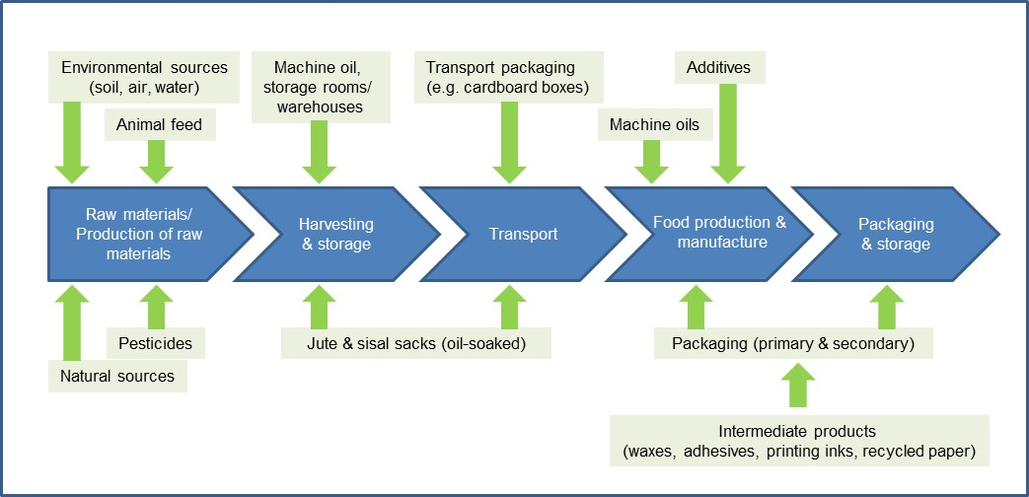

**≠** Adapted from Holst, 2017

MOH vary in size and structure, comprising 10 to approximately 50 carbon atoms[2]. They are categorised into two main groups referred to as either saturated or aromatic hydrocarbons, herein referred to as MOSH (Mineral Oil Saturated Hydrocarbons) and MOAH (Mineral Oil Aromatic Hydrocarbons), respectively. MOSH contains two groups with distinct structures; the straight and branched alkanes (e.g. paraffins) and the cycloalkanes (e.g. naphthenes). In contrast, MOAH comprise at least one aromatic ring which may be alkylated (Attachment 1).

## The use of mineral oils by the food industry

Highly refined, clear mineral oils that are used by the food industry are often referred to as ‘white’ oils. They have a number of practical applications, including:

* food processing, bottling and canning equipment
* food contact materials
* protective coating for raw fruits and vegetables
* eggshell sealant
* dust suppressant for grain or animal feed.

Mineral oils are also a significant component of offset printing inks (approx. 20-30%) which are used in food packaging. Cold-set printing processes are traditionally used for paperboard food packaging boxes. The inks in the packaging dry by absorption into the fibres. Approximately

1-50% of the MOH in offset printing inks are MOAH, due to its solubility characteristics (EFSA 2012).

Alternatively, paperboard can also be dried with hot-set printing techniques which results in the solvent evaporating, rather than being absorbed into the fibres.

Cold-set packaged products are commonly stacked into larger containers and transported on a pallet. Given the compact nature of the pre-market product, volatile MOH cannot easily evaporate out from the paperboard into the air, but instead can only be absorbed into the contents of the package. The packaging industry has adapted to account for this, using inner bags that act as barriers. Effective barriers include: aluminium bags, polyethylene terephthalate (PET), metallised or coated polyvinylidene chrloride, silicium oxide and aluminium oxide.

Recycled paper and board are commonly used by many companies in the food packaging industry. While the re-use of paper and board is environmentally friendly, recycling heavily printed items such as newpapers, produces products with high levels of MOH and other chemicals used in the packaging process. Some glues and adhesives used in assembling food packaging boxes also contain MOHs.

## Factors which can influence MOH transfer from packaging to food

There are a number of factors which can influence the levels of transfer of MOH into foods from packaging, including:

* shelf life, storage time and conditions (e.g. temperature) (Biedermann et al. 2013a; Vollmer et al. 2011; Biedermann, Grob 2012; Lorenzini et al. 2013; Triantafyllou et al. 2007; Lorenzini et al. 2010; Dima et al. 2011)
* packaging materials used (recycled versus virgin fibres; presence or absence of inner linings and their composition) (Biedermann et al. 2013a; Vollmer et al. 2011; Biedermann, Grob 2012; Lorenzini et al. 2013; Lommatzsch et al. 2016; Biedermann et al. 2011; Droz, Grob 1997)
* food matrix characteristics (e.g. fat content and porosity) (Triantafyllou et al. 2007; Biedermann, Grob 2012; Biedermann et al. 2013b; Biedermann-Brem, Grob 2011).

## Regulatory provisions for the use of mineral oils in food and packaging

Standard 1.3.3- Processing aids of the Code permits the use of mineral oil based greases and white mineral oil for the technological purposes of being a lubricant, release and anti-stick agent (FSANZ 2018b). While usage is permitted, levels should be in accordance with Good Manufacturing Practice (GMP) where levels are kept as low as possible to achieve the desired effect (Standard 1.1.2)[3] (FSANZ 2018a).

Standard 3.2.2 – Food Safety Practices and General Requirements of the Code specifies a requirement for food businesses to ensure that packaging material that are used are fit for purpose and are not likely to cause food contamination (FSANZ 2018c).

Other countries and Codex have more prescriptive requirements compared to Australia and New Zealand (Attachment 2).

***Hazard Characterisation***

No internationally agreed Health Based Guidance Values (HBGV) are currently available for MOH.

The Joint Food and Agriculture Organisation (FAO)/World Health Organisation (WHO) Expert Committee on Food Additives (JECFA) has previously established temporary acceptable daily intake (ADI) values for mineral oil (medium and low viscosity) classes II and III, however these were withdrawn in 2012 because requested data supporting establishment of a full ADI had not been made available (WHO 2012).

Because of the complexity of MOH mixtures it is not possible to separate these into individual components, or to base a hazard characterisation on single compounds or indicator substances. However, it is possible to distinguish between the MOSH and MOAH fractions.

EFSA (2012) has identified toxicological points of departure for MOSH that can be used as reference points in a margin of exposure evaluation. These reference points are based on no observed adverse effect levels (NOAELs) for liver effects in rats and vary depending on the grade of MOSH. The reference point identified for the most potent grades of MOSH (low and intermediate melting point waxes) was 19 mg/kg bw/day. The range of MOSH grades used in food uses such as release agents for bread and rolls and spraying of grain is more restricted, and the reference point for these grades for MOSH was identified as 45 mg/kg bw/day.

MOAH with 3-7 non- or simple-alkylated aromatic rings may be mutagenic and carcinogenic, while some highly alkylated MOAH can act as tumour promoters (EFSA 2012). As MOAH may be genotoxic and carcinogenic it is desirable that exposures to MOAH should be as low as reasonably achievable.

# Methodology

## Sampling

The survey was conducted in two phases.

#### Phase 1

Phase 1 analysed the level of mineral oil hydrocarbons in paperboard packaging from a total of 61 food products including pasta, cereals and grains, sugar, packet powders and cake mixes, tea, roasted nuts and berries and frozen items such as fish and chicken. An additional 5 samples each of paperboard packaging of known composition (100% recycled; 25% recycled; virgin) were obtained from industry sources to use as control samples.

For those samples where multiple purchases were made of the same product, sampling instructions were provided to the analytical laboratory as to where cardboard samples should be taken, as outlined in Figure 2.

### Figure 2: Sampling instructions for the analytical laboratory



***2.1.2 Phase 2***

Phase 2 analysed the cardboard packaging and food contents contained within for the level of MOH. Food and packaging samples were selected based on the findings from Phase 1. Given the focus of this survey was to investigate MOH in food as a result of chemical migration from packaging, foods where there are provisions for MOH use as a food additive, were excluded.

The following criteria were used to assist in the selection of food samples:

* products in paperboard packaging with no internal bag were included first followed by products with recycled packaging
* foods highly consumed in the Australian population and common household brands were included
* cereals that identified as using 95 or 100% recycled materials or that contained no inner lining were included
* foods that are heated in their packaging or transferred to packaging after cooking (e.g. pizza) were considered to have a higher migration potential.
* foods that have previously demonstrated to have a high occurrence of MOAH/MOSH in previous studies were included, as far as practicable.

A total of 112 analyses were conducted with most foods sampled in the ACT, as these products are distributed nationally with minimal regional variation. Pizza and egg samples were collected by the analytical laboratory in Victoria. Pizza samples remained in the box for 1hr prior to being prepared for analyses.

## Sample preparation

Food samples were analysed as purchased, directly from the packaging in the dried state. No food preparation was undertaken prior to analysis.

***2.2.1 Analysis***

FSANZ engaged the National Measurement Institute (NMI) to analyse packaging and food samples for total MOSH and MOAH levels.

Food and paperboard extractions were undertaken in accordance with the method published by the German Institute for risk assessment (BfR 2012).

In brief, MOH are extracted under alkaline conditions followed by separation of the individual MOH (i.e. MOSH and MOAH) using a solid phase silver nitrate/silica gel followed by gas chromatography and flame ionisation detection for quantitation.

The Limit of Quantification (LOQ) for all MOHs analysed in paperboard and food was 10 mg/kg and the Limit of Detection (LOD) was 5 mg/kg.

# Results

## Phase 1: Quantification of MOH in paperboard packaging only

The first phase of this survey examined the level of MOH in food packaging. Samples were analysed for both total MOAH and MOSH, which are presented in Attachment 3.

Key findings:

* A total of 61 paperboard packaging samples were analysed in the initial phase from which a strong correlation was found between the level of MOH detected and the proportion of recycled material used in the packaging.
* MOSH was detected in over 90% of the food packaging samples tested. Levels ranged from 12 to 2900 mg/kg. Generally, higher levels of MOSH were found in packaging which was derived from recycled materials, with highest concentrations detected in packaging derived from 100% recycled products.
* There is a strong correlation between the level of MOH detected and the proportion of recycled material used in the packaging construction.
* These findings are consistent with the control packaging samples containing recycled materials. In addition, in most cases, packaging which contained recycled materials also used an inner lining as a physical barrier between the package and the food.
* There were a number of packaging products analysed for MOAH and MOSH in this phase of the survey which did not declare whether recycled materials were used in the packaging and therefore it is very difficult to draw any conclusions about these samples.

## Phase 2: The analysis of MOH in food packaging and products contained within

The second phase of the survey examined the level of MOH in food and their packaging. A total of 56 food samples and associated packaging were analysed for both total MOAH and MOSH, which are presented in Attachment 4.

Key findings:

* Fifty six dried unprepared food samples were analysed and the associated packaging for total MOSH and MOAH. Over 98% of the food samples tested had MOSH concentration levels at or below the Limit of Quantification (LOQ) of 10 mg/kg. One sample of dry chocolate cake mix was found to have a total MOSH level of 71 mg/kg.
* The same 56 food samples and packaging were also analysed for total MOAH, with over 92% of food samples found to contain MOAH at or below the LOQ of 10 mg/kg. Detections above the LOQ were found in couscous (85 mg/kg) and three samples of chocolate cake (150, 17, 77 mg/kg). Total MOAH was detected in approximately 90% of the corresponding food packaging, with concentration levels ranging from 11 to 9600 mg/kg. The packaging composition with the highest concentration of MOAH was not indicated on the product.

## Additional analysis of MOSH and MOAH in chocolate cake

Packet chocolate cake mix purchased at retail, generally contains two different sachets, one for the cake mix and the other for icing. The values for ‘chocolate cake’ presented in Attachment 4 represents a calculated value derived from individual analytical results of the cake mix and icing. Individual analytical results of the cake mix and icing mix are presented separately in Attachment 5.

In 100% of icing mix samples, neither total MOSH nor MOAH were detected above the LOQ of 10 mg/kg. In contrast, one sample of cake mix had a total MOSH concentration of 71 mg/kg, and all three cake mixes analysed had a total MOAH concentration ranging from 17 – 160 mg/kg.

## Relevance of results to health risk assessment

MOSH and/or MOAH were only detected in two food types tested indicating the levels of these compounds in Australian foods as a result of migration from food packaging are very low.

On the basis of the low incidence of detections in sampled foods a quantitative risk assessment was not justified. It is concluded that the levels of MOSH and MOAH in the Australian food supply due to migration from food packaging are unlikely to be of public health concern.

## Discussion

This survey analysed the concentration of MOSH and MOAH in packaging and food samples. In general, over 90% of food samples either MOSH or MOAH were not detected, with the exception of one sample of couscous and the three samples of chocolate cake mix.

In relation to the couscous sample, there were no detections of MOSH, however one sample contained 85 mg/kg of MOAH. This food sample did not contain an internal bag, so the product was in direct contact with the food packaging which had a MOAH concentration of 300 mg/kg. It is unclear from the product whether this food packaging was derived from virgin or recycled materials.

For the chocolate cake samples analysed, one of three samples had detectable MOSH in the powdered mix. MOAH was detected in all 3 samples, with concentrations ranging from 17 to 160 mg/kg.

Most commercially available cake mixes contain two sachets, one for the cake mix and the other for the icing. Individual analysis of each cake mix and icing sachet was undertaken and in each case, MOAH was detected above the LOR in the cake mix sachet only. In each sample, the MOAH levels in the dry icing mix were found to be at or below the LOR of 10 mg/kg.

Although MOH were detected in couscous and cake mix samples, the source of the MOH cannot be definitively determined by this study. The extensive processes used to generate couscous and cake mix for sale at the retail level, make it very difficult to conclude whether the MOH detections in the food is a result of chemical migration from food packaging or environmental contamination which occurred during the food manufacturing processes.

There is some relationships between MOH of specific carbon length (C*x*) associated with different sources of contamination, however the boundaries are not clear and there is significant overlap. The Figure below demonstrates the breadth of this variation for some sources.

### A comparison of the typical structures of MOH and associated sources, and the forms detected in the current study.

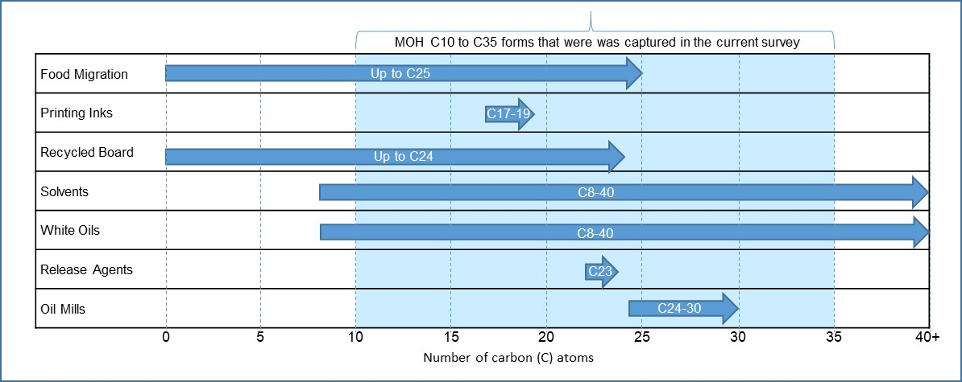

Given the analytical method used in this survey captured MOH forms ranging from C*10* to C*35*, it is difficult to delineate whether the detections of MOSH and MOAH in couscous or cake mix are a result of chemical migration into the food from packaging or a result of another form of exposure of the food to MOH during the manufacturing process.

Regardless of the source, the detection of MOH in wheat based or cocoa products is not uncommon. A number of studies have demonstrated the presence of MOSH and/or MOAH in semolina (a course precursor to couscous), couscous, baking mixes and cocoa (Vollmer et al. 2011; Biedermann-Brem, Grob 2011; Biedermann et al. 2013a; Barp et al. 2015a, 2015b).

The findings of this survey indicate that the levels of MOSH and MOAH in the Australian food supply due to migration from food packaging are very low and unlikely to be of public health concern. While MOH is approved for use in food manufacturing in Australia, it is important that the levels of MOAH be kept as low as reasonably achievable. FSANZ is aware of industry efforts to minimise the migration of these substances from food packaging into food[4] and will continue to monitor this issue.

**ATTACHMENT 1**

The basic structural difference between MOSH and MOAH are depicted in Figure 1. The composition of the various types of MOH is dependent on the origin of the crude mineral oil that is used as the starting material, in addition to subsequent processing procedures at the refinery.

### Figure 1: The structural differences between MOSH and MOAH≠.

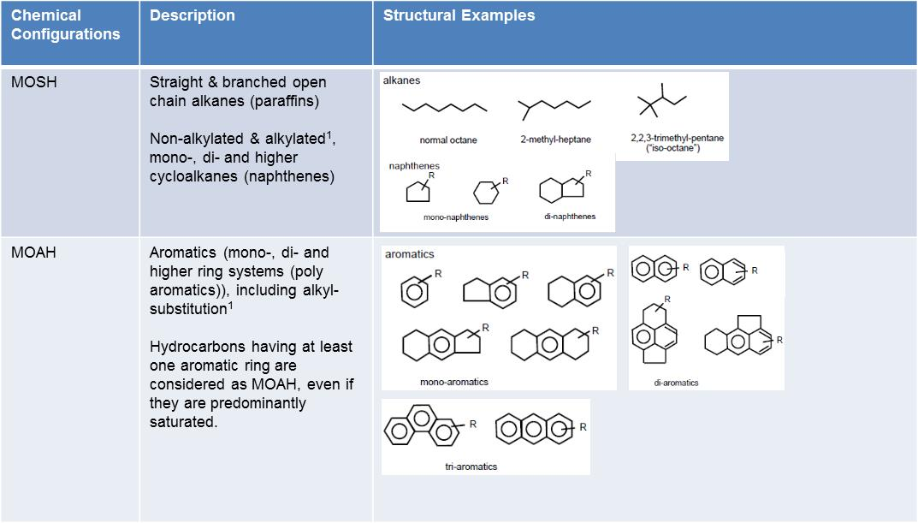

**≠** Adapted from (EFSA 2012)

**ATTACHMENT 2**

More specific provisions for the use of mineral oils in food and packaging are stipulated by international regulatory counterparts. For example, the US permits the use of white mineral oil in a number of food manufacturing processes, specifying levels in some cases (Table 1) (U.S GPO 2017)

International food standards set out by Codex is also more prescriptive in the permissions for the use of white mineral oils in food. MOH are categorised into high and medium viscosity mineral oil, for which the permissions vary between the two forms (Table 2) (Codex 1995). Categorisation of MOH based on physio-chemical properties is common; however it provides little information about the chemical composition of the MOH.

**Table 1: US permissions for the use of white mineral oil in food manufacturing†**

| Use | Limitation (inclusive of all petroleum hydrocarbons that may be used in combination with white mineral oil) |
| --- | --- |
| 1. As a release agent, binder, and lubricant in or on capsules and tablets containing concentrates of flavoring, spices, condiments, and nutrients intended for addition to food, excluding confectionery | Not to exceed 0.6% of the capsule or tablet. |
| 2. As a release agent, binder, and lubricant in or on capsules and tablets containing food for special dietary use | Not to exceed 0.6% of the capsule or tablet. |
| 3. As a float on fermentation fluids in the manufacture of vinegar and wine to prevent or retard access of air, evaporation, and wild yeast contamination during fermentation | In an amount not to exceed good manufacturing practice. |
| 4. As a defoamer in food | In accordance with §173.340 of this chapter. |
| 5. In bakery products, as a release agent and lubricant | Not to exceed 0.15% of bakery products. |
| 6. In dehydrated fruits and vegetables, as a release agent | Not to exceed 0.02% of dehydrated fruits and vegetables. |
| 7. In egg white solids, as a release agent | Not to exceed 0.1% of egg white solids. |
| 8. On raw fruits and vegetables, as a protective coating | In an amount not to exceed good manufacturing practice. |
| 9. In frozen meat, as a component of hot-melt coating | Not to exceed 0.095% of meat. |
| 10. As a protective float on brine used in the curing of pickles | In an amount not to exceed good manufacturing practice. |
| 11. In molding starch used in the manufacture of confectionery | Not to exceed 0.3 percent in the molding starch. |
| 12. As a release agent, binder, and lubricant in the manufacture of yeast | Not to exceed 0.15 percent of yeast. |
| 13. As an antidusting agent in sorbic acid for food use | Not to exceed 0.25 percent in the sorbic acid. |
| 14. As release agent and as sealing and polishing agent in the manufacture of confectionery | Not to exceed 0.2 percent of confectionery. |
| 15. As a dust control agent for wheat, corn, soybean, barley, rice, rye, oats, and sorghum | Applied at a level of no more than 0.02 percent by weight of grain. |
| 16. As a dust control agent for rice | ISO 100 oil viscosity (100 centistokes (cSt) at 100 °F) applied at a level of no more than 0.08 percent by weight of the rice grain. |

**†** Taken from (U.S GPO 2017)

**Table 2: Codex General Standard for Food Additives∞**

|  |  |  |
| --- | --- | --- |
| Food category | Mineral oil viscosity | |
| High  (905d) | Medium  (905e) |
| Bakery wares† | ✓ | ✓ |
| Breads and rolls**†** |  | ✓ |
| Chewing gum | ✓ |  |
| Cocoa products and chocolate products including imitations and chocolate substitutes‡ | ✓ |  |
| Confectionery**‡** |  | ✓ |
| Confectionery including hard and soft candy, nougats etc other than food categories 05.1, 05.3, 05.4 | ✓ |  |
| Decorations (e.g. fine bakery wares), toppings (non-fruit) and sweet sauces¥ | ✓ |  |
| Dried fruit | ✓ | ✓ |
| Frozen processed comminuted meat, poultry and game products**¥** | ✓ |  |
| Frozen processed meat, poultry, and game products in whole pieces or cuts**¥** | ✓ |  |
| Whole, broken or flaked grain, including rice **(for use as dust control only)** | ✓ |  |

**∞** (Codex 1995)

**†** As a releasing agent only

**‡** For surface treatment only; excludes products captured in (Codex 1981b, 1981a, 1981c, 1983)

**¥** For surface treatment only

**ATTACHMENT 3**

A summary of results is as follows:

* MOAH and MOSH were detected in all food packaging samples, however only cereals, custard powder & cake mix had an inner bag to reduce the level of mineral oil migration. Overall, MOSH levels were generally higher than MOAH in actual food packaging tested.
* The highest concentration of total MOAH of 3200 mg/kg was detected in chocolate cake packaging which was derived from 95% recycled materials. This level was approximately 2-fold higher than MOAH levels detected in 100% recycled packaging control samples.
* The highest concentration of total MOSH of 7300 mg/kg was detected in tea packaging which was derived from 95% recycled materials. This level was over 25% higher than MOSH levels detected in 100% recycled packaging control samples.
* Based on the control sample data presented in Table 1, the level of MOAH and MOSH is generally higher in paperboard containing any recycled component, in comparison to virgin cardboard control samples. There is a direct relationship between the proportion of recycled component and an increase in the level of MOAH and MOSH.

### Table 1: Total MOAH and total MOSH concentration ranges in food packaging available in Australia.

| Food Packaging Type  (n=x) | Packaging Type used | | Food Packaging Concentration Range  (mg/kg) | |
| --- | --- | --- | --- | --- |
| **Paperboard** | **Internal bag** | **Total MOSH†** | **Total MOAH†** |
| Risoni (5) | Not indicated | No | 140 - 380 | 60 - 560 |
| Pasta/Spelt (4) | Not indicated | No | 120 - 3900 | 330 - 710 |
| Not indicated | Yes | 540 | 320 |
| Cous Cous (6) | Not indicated | No | 180 - 790 | <10 - 290 |
| Oats (5) | Not indicated | No | <10 - 810 | 30 - 210 |
| Breakfast cereal, multiple grain (5) | 95% recycled | Yes | 600 - 2400 | 360 - 1100 |
| Breakfast cereal, single grain (5) | 100% recycled | Yes | 2400 - 4900 | 210 - 1100 |
| Bread crumbs (5) | Not indicated | No | 60 - 560 | <10 - 200 |
| Sugar (5) | Not indicated | No | 520 - 1000 | 10 - 460 |
| Custard powder (5) | Not indicated | Yes | <10 - 400 | 10 – 910 |
| Cake mix, chocolate (3) | Not indicated (1) | Yes | 310 | 250 |
| 95% recycled (2) | Yes | 3200 - 7000 | 440 - 3200 |
| Cake mix, vanilla (2) | 95% recycled | Yes | 6400 | 560 |
| Not indicated | Yes | 5300 | 710 |
| Nuts/dried fruit mix (5) | Not indicated | No | 110 - 500‡ | <10 - 310 |
| Tea (1) | 95% recycled | No | 7300 | 540 |
| Fish, battered/ frozen (3) | Not indicated | No | 290 - 430 | 70 - 200 |
| Chicken, battered/ frozen (2) | Not indicated | No | 270 - 320 | 70 - 110 |
| CONTROL PAPERBOARD SAMPLES | | | | |
| Kraft + 25% recycled (5) | N/A | N/A | 570 - 1800 | 90 - 870 |
| 100% recycled cardboard (5) | N/A | N/A | 4200 - 5700 | 530 - 1600 |
| 100% virgin cardboard (5) | N/A | N/A | 90 - 120 | <10 - 610 |

† Total values are for detects of the C10 – C35 forms; ‘X’ denotes the number of samples tested;

LOQ= 10 mg/kg; LOD= 5 mg/kg. ‡ One sample was not tested by the analytical laboratory for total MOSH

**ATTACHMENT 4**

A summary of results is as follows:

* Over 98% of the food samples tested for total MOSH, had concentration levels at or below the LOQ of 10 mg/kg (Table 1). One sample of chocolate cake mix was found to have a total MOSH level of 71 mg/kg.
* For food packaging analysed in phase two of the survey, total MOSH was detected in over 90% of the 56 samples tested. Levels ranged from 12 to 2900 mg/kg. Generally, higher levels of MOSH were found in packaging which was derived from recycled materials, with highest concentrations detected in packaging derived from 100% recycled products.
* The same 56 food samples and packaging were also analysed for total MOAH, with over 92% of food samples found to contain MOAH at or below the LOQ of 10 mg/kg. Detections above the LOQ were found in couscous (85 mg/kg) and three samples of chocolate cake (17, 77, 150 mg/kg).
* Total MOAH was detected in approximately 90% of the corresponding food packaging, with concentration levels ranging from 11 to 9600 mg/kg. The composition of the packaging which had the highest concentration of MOAH detected, was not indicated.

### Table 1: Total MOSH and MOAH concentrations in food and packaging available in Australia*

|  |  |  |  |  |  |
| --- | --- | --- | --- | --- | --- |
| Food Type (n=X) | Sample Type | *MOSH* | | *MOAH* | |
| ***Number of Detects >LOQ*** | ***Total Food and/or Packaging Concentration Range*†**  **(mg/kg)** | ***Number of Detects >LOQ*** | ***Total Food and/or Packaging Concentration Range*†**  **(mg/kg)** |
| Pasta (n=5) | Food | 0 | **-** | 0 | **-** |
| Packaging | 5 | 44-420 | 2 | 54-150 |
| Cous Cous (n=3) | Food | 0 | **-** | 1 | 85 |
| Packaging | 3 | 29-720 | 3 | 78-300 |
| Oats (n=3) | Food | 0 | **-** | 0 | **-** |
| Packaging | 1 | 34 | 2 | 11-12 |
| Breakfast cereal, multiple grain (n=3) | Food | 0 | **-** | 0 | **-** |
| Packaging | 3 | 61-630 | 3 | 250-660 |
| Breakfast cereal, single grain (n=9) | Food | 0 | **-** | 0 | **-** |
| Packaging | 9 | 23-1000 | 9 | 110-9600 |
| Bread crumbs (n=3) | Food | 0 | **-** | 0 | **-** |
| Packaging | 2 | 18-88 | 2 | 39-120 |
| Sugar (n=3) | Food | 0 | **-** | 0 | **-** |
| Packaging | 3 | 55-160 | 3 | 100-190 |
| Flour, Plain (n=3) | Food | 0 | **-** | 0 | **-** |
| Packaging | 3 | 54-92 | 3 | 150-180 |
| Cake mix, chocolate (n=3) | Food | 1 | 71 | 3 | 17-150 |
| Packaging | 3 | 12-2200 | 3 | 20-320 |
| Chicken, battered/frozen (n=3) | Food | 0 | **-** | 0 | **-** |
| Packaging | 1 | 14 | 3 | 14-47 |
| Fish, battered/frozen (n=3) | Food | 0 | **-** | 0 | **-** |
| Packaging | 3 | 26-120 | 3 | 130-270 |
| Sausage rolls (n=3) | Food | 0 | **-** | 0 | **-** |
| Packaging | 3 | 25-75 | 3 | 64-81 |
| Box, Pizza, take away (n=6) | Food | 0 | **-** | 0 | **-** |
| Packaging | 6 | 110-2900 | 5 | 280-920 |
| Eggs (n=2) | Food | 0 | **-** | 0 | **-** |
| Packaging | 2 | 180-630 | 2 | 220-370 |
| Infant cereal (n=4) | Food | 0 | **-** | 0 | **-** |
| Packaging | 4 | 400-1400 | 4 | 430-680 |

† Total values are for detects of the C10 – C35 forms; ‘X’ denotes the number of samples tested; - indicates that there is no range as there were no detections above the LOQ; LOQ= 10 mg/kg & LOD= 5 mg/kg for all samples analysed.* All foods were analysed raw, uncooked, dry or unprepared.

**ATTACHMENT 5**

### Total MOSH and MOAH concentrations in chocolate cake mix and icing available in Australia*

|  |  |  |  |  |
| --- | --- | --- | --- | --- |
| Sample no. | Total MOSH (mg/kg) | | Total MOAH (mg/kg) | |
| ***Cake mix*** | ***Icing mix*** | ***Cake mix*** | ***Icing mix*** |
| 1 | **<10** | **<10** | **160** | **<10** |
| 2 | **<10** | **<10** | **17** | **<10** |
| 3 | **71** | **<10** | **75** | **<10** |

* All foods were analysed raw, uncooked, dry or unprepared.

1. [http://www.foodstandards.gov.au/code/proposals/Pages/P1034ChemicalMigrationfromPackagingintoFood.aspx](https://admin-www.foodstandards.gov.au/code/proposals/Pages/P1034ChemicalMigrationfromPackagingintoFood.aspx)
2. Referred to as C*x*, where *‘x’* is the number of carbon atoms present in the structure.
3. ***GMP*** or ***Good Manufacturing Practice***, with respect to the addition of substances used as food additives and

   substances used as processing aids to food, means the practice of:

   (a) limiting the amount of substance that is added to food to the lowest possible level necessary to accomplish its desired effect; and

   (b)  to the extent reasonably possible, reducing the amount of the substance or its derivatives that:

               (i)  remains as a *component of the food as a result of its use in the manufacture, processing or packaging; and

                 (ii)  is not intended to accomplish any physical or other technical effect in the food itself;

       (c)  preparing and handling the substance in the same way as a food ingredient.
4. [Statement of the European Printing Ink Association](http://www.eupia.org/index.php?id=31&tx_edm_pi1%5BshowUid%5D=21&cHash=6495d86ce2d7a8022a1802b356c4fd2a)